ish¿u ysñlï weúßKs $ All Rights Reserved

St. Peter's College

St. Peter's College

St. Peter's College

புனித பேதுரு கல்லூரி

புனித பேதுரு கல்லூரி

புனித பேதுரு கல்லூரி

புனித பேதுரு கல்லூரி

புனித பேதுரு கல்லூரி

புனித பேதுரு கல்லூரி

புனித பேதுரு கல்லூரி

புனித பேதுரு கல்லூரி

Ydka; mS;r úÿy,

Ydka; mS;r úÿy,

Ydka; mS;r úÿy,

Ydka; mS;r úÿy,

Ydka; mS;r úÿy,

Ydka; mS;r úÿy,

Ydka; mS;r úÿy,

Ydka; mS;r úÿy,

Ydka; mS;r úÿy,

Ydka; mS;r úÿy,

St. Peter's College

St. Peter's College

St. Peter's College

St. Peter's College

St. Peter's College

St. Peter's College

St. Peter's College

St. Peter's College

St. Peter's College

St. Peter's College

புனித பேதுரு கல்லூரி

புனித பேதுரு கல்லூரி

புனித பேதுரு கல்லூரி

புனித பேதுரு கல்லூரி

புனித பேதுரு கல்லூரி

புனித பேதுரு கல்லூரி

புனித பேதுரு கல்லூரி

புனித பேதுரு கல்லூரி

Ydka; mS;r úÿy,

Ydka; mS;r úÿy,

Ydka; mS;r úÿy,

Ydka; mS;r úÿy,

Ydka; mS;r úÿy,

Ydka; mS;r úÿy,

Ydka; mS;r úÿy,

Ydka; mS;r úÿy,

Ydka; mS;r úÿy,

Ydka; mS;r úÿy,

St. Peter's College

St. Peter's College

St. Peter's College

St. Peter's College

St. Peter's College

St. Peter's College

St. Peter's College

31

E

**I**

**bx.%Sis NdIdj** ¸

**English Language - I**

**meh 02**

**Two Hour**

**11 fY%aKsh – m<uq jdr we.hsu - 2023**

***Grade 11 – First Term Examination - 2023***

Ydka; mS;r úÿy, - fld<U 04

புனித பேதுரு கல்லூரி, கொழும்பு 4

***St. Peter's College - Colombo 04***



Name: ………………………………………………. Class: …………… Index No: ………….

**Test – 1**

Fill in the blanks of the following text using the words given in the brackets. **One is done for you.**

**EASSAY COMPETITION**

An essay competition was held (1). __________________ (next week , last week) for the children of the age 13 to 16 years old. All (2). __________________ (competitions , competitors) were invited to attend a (3). ___________________________ (train , training) session held at Asoka Vidyalaya (4). __________________ (beside , before) the competition. Competitors were asked to write essays on given topics. The (5). __________________ (good , best) essays were selected by the judges. Winners were awarded valuable prizes. (6). __________________ (There , Their) names were published in the newspapers.

***(05 Marks)***

**Test – 2**

Fill in the blanks in the following dialogue between a patient and a doctor. Use the words given in the box. Write the correct letter in the blank. **The first one is done for you.**

a). temperature b). better c). wrong d). symptoms

e). severe f). suffering

Patient : Good Morning! Doctor.

Doctor : Good Morning! What’s **1. _____c____** with you?

Patient : I’ve been 2. ____________ from fever since yesterday.

Doctor : Any other 3. ____________ ?

Patient : I have a 4. ____________ headache too.

Doctor : Let me take your body 5. ____________. Alright, have some rest and take the tablets on time. You’ll feel 6. ____________

Patient : Thank you, Doctor. ***(05 Marks)***

**Test – 3**

Study the picture and describe it with 05 sentences using appropriate vocabulary and tenses.

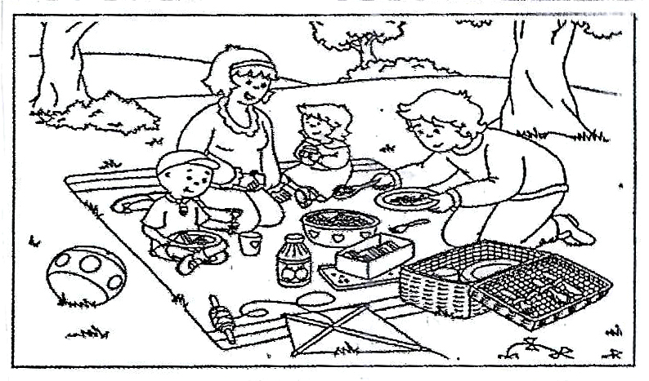

________________________________________________________________________________________________________________________________________________________________________________________________________________________________________________________________________________________________________________________________________________________________________________________________________________________________________________________________________________________________

***(05 Marks)***

**Test – 4**

Write a paragraph on one of the following use about 50 -60 words.

1. The job I like most.

2. The value of good friends.

3. A journey by train.

________________________________________________________________________________________________________________________________________________________________________________________________________________________________________________________________________________________________________________________________________________________________________________________________________________________________________________________________________________________________________________________________________________________________________________

***(05 Marks)***

**Test – 5**

Read the following text and answer the questions given below.

Kasun jumped from bed as soon as the first rays of the sun peeped through his windows. He took his travel bag from his cupboard and started putting things in it. He put his favourite T – shirts and trousers, the two books “Birds of Sri Lanka” and “Young Artists”. After a quick shower, he was ready to go with his grandfather.

Going to visit his grandparents for a week has always been the best part of his school holidays. Grandfather would always take him round his village to meet his old friends there. He would also take him to bathe in the river.

Last year when Kasun was 15 years old he climbed the hill behind the house. Of course, grandfather was the leader of their group of “hill climbers”. He also learnt to fix a broken tap in the garden in addition to many other things around the house. Grandfather was always patient and did not mind taking many hours to teach Kasun various little things like mending fence and making vegetable beds.

Kasun’s mother called from the sitting room. “Grandfather’s here”.

Underline the correct answer.

1. Kasun went with grandfather

a). in the morning b). in the evening c). at night

write the answers in full sentence.

2. What are the title of the books Kasun took with him?

__________________________________________

__________________________________________

3. Why would grandfather take Kasun around his village?

__________________________________________

4. What are the various things that Kasun learnt from grandfather?

__________________________________________

5. Underline the meaning of the word ‘patient’ according to the text.

a). A person who doesn’t mind waiting.

b). A person who is not well.

c). A person who is always angry. ***(1 $×$ 5 $=$ 05 Marks)***

**Test – 6**

You are the secretary of the science society of your school. You have planned to invite a Guest speaker, Dr. Nimal Perera, a lecturer of a University to speak to the members on Information Technology. Write a notice inviting the members. Use about 50 words.

Include the following date, time, place, name of the speaker.

___________________________________________

________________________________________________________________________________________________________________________________________________________________________________________________________________________________________________________________________________________________________________________________________________________________________________________________________________________________________________________________________________________________________________________________________________________________________________________________________________________________________________________________________________________________________________________________________________________________________________________________________________________________________________________________________________________________________________________________________________________________________________________________

***(05 Marks)***